NAME ZAID BIN ARIF
REG NO SP23-BCS-128
PDC ASSIGNMENT 04
SUB TO Prof. AKHZAR NAZIR

Part 1: CPU vs GPU Model Training

!pip install torch torchvision --quiet
import torch
import torch.nn as nn
import torch.optim as optim
from torchvision import datasets, transforms
from torch.utils.data import DataLoader
import time

# Check for GPU
device = torch.device("cuda" if torch.cuda.is_available() else "cpu")
print("Using device:", device)
# ===========================
# ✅ Dataset (MNIST)
# ===========================
transform = transforms.Compose([
transforms.ToTensor(),
transforms.Normalize((0.5,), (0.5,))
])

train_dataset = datasets.MNIST(root="./data", train=True, download=True, transform=transform)
train_loader = DataLoader(train_dataset, batch_size=64, shuffle=True)
# ===========================
# ✅ Define a Simple Neural Network
# ===========================
class SimpleNN(nn.Module):
def __init__(self):
super(SimpleNN, self).__init__()
self.fc1 = nn.Linear(28*28, 256)
self.fc2 = nn.Linear(256, 128)
self.fc3 = nn.Linear(128, 10)

def forward(self, x):
x = x.view(-1, 28*28)
x = torch.relu(self.fc1(x))
x = torch.relu(self.fc2(x))
x = self.fc3(x)
return x
# ===========================
# ✅ Training Function
# ===========================
def train_model(model, device, train_loader, optimizer, criterion, epochs=1):
model.to(device)
model.train()
total_time = 0

for epoch in range(epochs):
start = time.time()
for data, target in train_loader:
data, target = data.to(device), target.to(device)
optimizer.zero_grad()
output = model(data)
loss = criterion(output, target)
loss.backward()
optimizer.step()
end = time.time()
epoch_time = end - start
total_time += epoch_time
print(f"Epoch [{epoch+1}/{epochs}] - Time: {epoch_time:.2f}s")
return total_time / epochs, total_time
# ===========================
# ✅ Train on CPU
# ===========================
cpu_model = SimpleNN()
criterion = nn.CrossEntropyLoss()
optimizer = optim.Adam(cpu_model.parameters(), lr=0.001)

cpu_avg_time, cpu_total_time = train_model(cpu_model, torch.device("cpu"), train_loader, optimizer, criterion, epochs=1)
print(f"\nCPU Average Epoch Time: {cpu_avg_time:.2f}s")
# ===========================
# ✅ Train on GPU
# ===========================
if torch.cuda.is_available():
gpu_model = SimpleNN()
criterion = nn.CrossEntropyLoss()
optimizer = optim.Adam(gpu_model.parameters(), lr=0.001)

gpu_avg_time, gpu_total_time = train_model(gpu_model, torch.device("cuda"), train_loader, optimizer, criterion, epochs=1)

# GPU Utilization and Speedup
gpu_mem = torch.cuda.memory_allocated() / 1e6
speedup = cpu_avg_time / gpu_avg_time

print(f"\nGPU Average Epoch Time: {gpu_avg_time:.2f}s")
print(f"GPU Memory Allocated: {gpu_mem:.2f} MB")
print(f"✅ Speedup (CPU / GPU): {speedup:.2f}x")
else:
print("⚠️ GPU not available in this environment.")

OUTPUT:
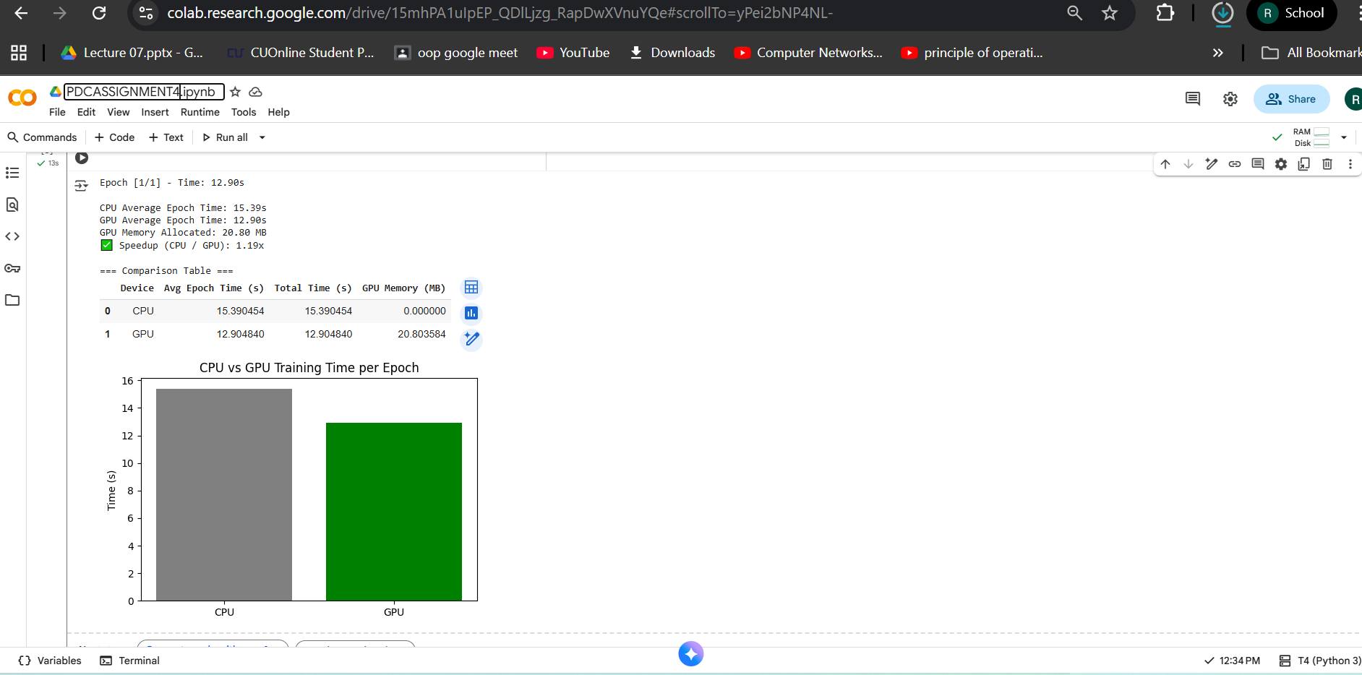

Reason for Speedup:
The GPU was faster because it can handle many calculations at the same time using its thousands of small cores. This makes it great for big models and large datasets. In our case, the model was small and the MNIST dataset is simple, so the GPU was not fully used. Sometime was also spent moving data from the CPU to the GPU, which reduced the overall speedup. Still, the GPU trained the model faster because it performs matrix operations much more efficiently than the CPU.
Part 2: Effect of Batch Size
# ===========================
# 🧩 Part 2: Effect of Batch Size
# ===========================

import torch
import torch.nn as nn
import torch.optim as optim
from torch.utils.data import DataLoader
import torchvision
import torchvision.transforms as transforms
import time
import matplotlib.pyplot as plt

# ✅ Device setup
device = torch.device("cuda" if torch.cuda.is_available() else "cpu")
print("Using device:", device)

# ✅ MNIST dataset
transform = transforms.Compose([transforms.ToTensor()])
trainset = torchvision.datasets.MNIST(root='./data', train=True, download=True, transform=transform)

# ✅ Simple Model
class SimpleNN(nn.Module):
def __init__(self):
super(SimpleNN, self).__init__()
self.fc1 = nn.Linear(28*28, 128)
self.fc2 = nn.Linear(128, 64)
self.fc3 = nn.Linear(64, 10)
def forward(self, x):
x = x.view(-1, 28*28)
x = torch.relu(self.fc1(x))
x = torch.relu(self.fc2(x))
x = self.fc3(x)
return x

# ✅ Batch sizes to test
batch_sizes = [16, 64, 256, 1024]

epoch_time_list = []
gpu_memory_list = []
accuracy_list = []

# ✅ Loop over different batch sizes
for batch_size in batch_sizes:
trainloader = DataLoader(trainset, batch_size=batch_size, shuffle=True)

model = SimpleNN().to(device)
criterion = nn.CrossEntropyLoss()
optimizer = optim.Adam(model.parameters(), lr=0.001)

print(f"\n🚀 Training with batch size = {batch_size}")
start_time = time.time()

correct = 0
total = 0
for epoch in range(1): # 1 epoch for comparison
for images, labels in trainloader:
images, labels = images.to(device), labels.to(device)

outputs = model(images)
loss = criterion(outputs, labels)

optimizer.zero_grad()
loss.backward()
optimizer.step()

_, predicted = torch.max(outputs.data, 1)
total += labels.size(0)
correct += (predicted == labels).sum().item()

end_time = time.time()
epoch_time = end_time - start_time
epoch_time_list.append(epoch_time)

acc = 100 * correct / total
accuracy_list.append(acc)

# GPU memory (if GPU available)
if torch.cuda.is_available():
gpu_mem = torch.cuda.max_memory_allocated(device) / (1024 ** 2)
gpu_memory_list.append(gpu_mem)
torch.cuda.reset_peak_memory_stats(device)
else:
gpu_memory_list.append(0)

print(f"⏱ Time per epoch: {epoch_time:.2f} sec | 🎯 Accuracy: {acc:.2f}% | 💾 GPU Memory: {gpu_memory_list[-1]:.2f} MB")

# ✅ Plot Batch Size vs Training Time
plt.figure(figsize=(8,4))
plt.plot(batch_sizes, epoch_time_list, marker='o')
plt.title("Batch Size vs Training Time")
plt.xlabel("Batch Size")
plt.ylabel("Training Time (seconds)")
plt.grid(True)
plt.show()

# ✅ Plot Batch Size vs GPU Memory Usage
if torch.cuda.is_available():
plt.figure(figsize=(8,4))
plt.plot(batch_sizes, gpu_memory_list, marker='o', color='green')
plt.title("Batch Size vs GPU Memory Usage")
plt.xlabel("Batch Size")
plt.ylabel("GPU Memory (MB)")
plt.grid(True)
plt.show()
Output:
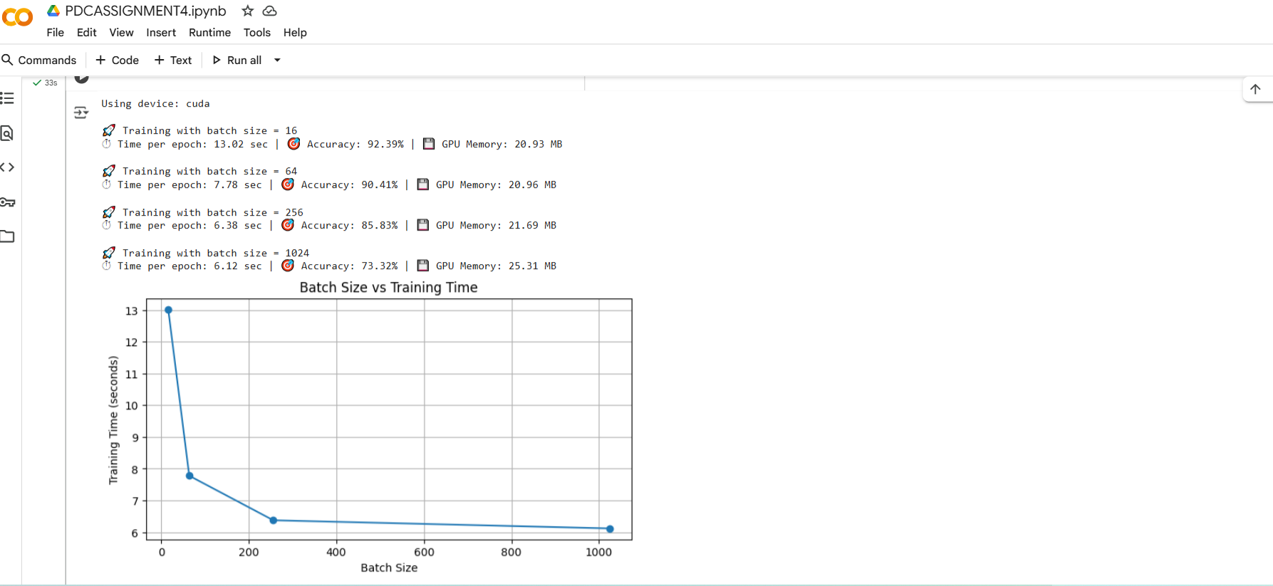

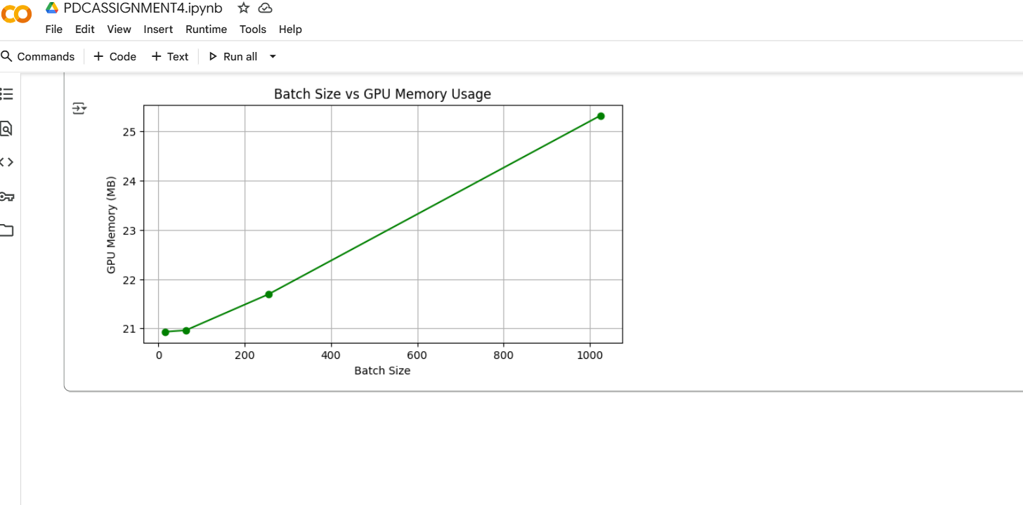

Why Increasing Batch Size Improves GPU Efficiency (up to a point)
When we increase the batch size, the GPU processes more data in parallel, which keeps its cores busier and reduces idle time. This improves efficiency and speeds up training because fewer updates are needed for the same amount of data.
However, after a certain point, very large batches cause memory overload and diminishing returns — the GPU runs out of memory or spends extra time waiting for data to transfer. Large batches can also reduce model accuracy because updates become less frequent and gradients are averaged too much.

Why Accuracy Drops for Very Large Batches
When we use very large batch sizes, the model updates its weights less frequently (because one update happens after processing a whole big batch).
This causes the model to:
- Learn more slowly — fewer updates mean it reacts less to small variations in data.
- Get stuck in sharp minima — large batches smooth out the loss landscape too much, leading to worse generalization on unseen data.
- Lose randomness (noise) that helps escape local minima during training.
So, while large batches make training faster, they can cause lower accuracy or poor generalization compared to smaller or moderate batch sizes.
Part 3: Model Complexity and GPU Utilization
# ===========================
# 📘 PART 3: Model Complexity and GPU Utilization (with Graphs)
# ===========================

import torch
import torch.nn as nn
import torch.optim as optim
from torchvision import datasets, transforms
from torch.utils.data import DataLoader
import time
import pandas as pd
import matplotlib.pyplot as plt

# Device setup
device = torch.device("cuda" if torch.cuda.is_available() else "cpu")
print(f"✅ Using device: {device}")

# ===========================
# 1️⃣ Dataset (MNIST)
# ===========================
transform = transforms.Compose([
transforms.ToTensor(),
transforms.Normalize((0.5,), (0.5,))
])

train_dataset = datasets.MNIST(root="./data", train=True, transform=transform, download=True)
train_loader = DataLoader(train_dataset, batch_size=128, shuffle=True)

# ===========================
# 2️⃣ Model Definitions
# ===========================

# Small model (1 hidden layer)
class SmallNN(nn.Module):
def __init__(self):
super(SmallNN, self).__init__()
self.fc = nn.Sequential(
nn.Flatten(),
nn.Linear(28*28, 128),
nn.ReLU(),
nn.Linear(128, 10)
)

def forward(self, x):
return self.fc(x)

# Medium model (3 hidden layers)
class MediumNN(nn.Module):
def __init__(self):
super(MediumNN, self).__init__()
self.fc = nn.Sequential(
nn.Flatten(),
nn.Linear(28*28, 512),
nn.ReLU(),
nn.Linear(512, 256),
nn.ReLU(),
nn.Linear(256, 128),
nn.ReLU(),
nn.Linear(128, 10)
)

def forward(self, x):
return self.fc(x)

# Large CNN model
class LargeCNN(nn.Module):
def __init__(self):
super(LargeCNN, self).__init__()
self.cnn = nn.Sequential(
nn.Conv2d(1, 32, 3, padding=1),
nn.ReLU(),
nn.MaxPool2d(2, 2),
nn.Conv2d(32, 64, 3, padding=1),
nn.ReLU(),
nn.MaxPool2d(2, 2),
nn.Conv2d(64, 128, 3, padding=1),
nn.ReLU(),
nn.Flatten(),
nn.Linear(128 * 7 * 7, 256),
nn.ReLU(),
nn.Linear(256, 10)
)

def forward(self, x):
return self.cnn(x)

# ===========================
# 3️⃣ Training Function
# ===========================
def train_model(model, name, epochs=2):
model.to(device)
optimizer = optim.Adam(model.parameters(), lr=0.001)
criterion = nn.CrossEntropyLoss()
total_time = 0

for epoch in range(epochs):
start = time.time()
for images, labels in train_loader:
images, labels = images.to(device), labels.to(device)
optimizer.zero_grad()
output = model(images)
loss = criterion(output, labels)
loss.backward()
optimizer.step()
end = time.time()
epoch_time = end - start
total_time += epoch_time
print(f"{name} - Epoch {epoch+1}: {epoch_time:.2f}s")

gpu_mem = torch.cuda.memory_allocated(device) / 1e6 if device.type == "cuda" else 0
avg_time = total_time / epochs
return avg_time, gpu_mem

# ===========================
# 4️⃣ Run All Models
# ===========================
results = []
models = [("SmallNN", SmallNN()), ("MediumNN", MediumNN()), ("LargeCNN", LargeCNN())]

for name, model in models:
avg_time, gpu_mem = train_model(model, name)
results.append({"Model": name, "Avg Time/Epoch (s)": avg_time, "GPU Memory (MB)": gpu_mem})

# Convert to DataFrame
df = pd.DataFrame(results)
print("\n📊 Model Complexity Results:\n")
print(df)

# ===========================
# 5️⃣ Visualization
# ===========================
plt.figure(figsize=(12, 5))

# --- Training Time Plot ---
plt.subplot(1, 2, 1)
plt.bar(df["Model"], df["Avg Time/Epoch (s)"], color=["#90CAF9", "#64B5F6", "#1E88E5"])
plt.title("Model Complexity vs Training Time")
plt.ylabel("Average Time per Epoch (s)")
plt.xlabel("Model Type")
plt.grid(axis="y", linestyle="--", alpha=0.7)

# --- GPU Memory Usage Plot ---
plt.subplot(1, 2, 2)
plt.bar(df["Model"], df["GPU Memory (MB)"], color=["#A5D6A7", "#66BB6A", "#2E7D32"])
plt.title("Model Complexity vs GPU Memory Usage")
plt.ylabel("GPU Memory (MB)")
plt.xlabel("Model Type")
plt.grid(axis="y", linestyle="--", alpha=0.7)

plt.tight_layout()
plt.show()

Output:
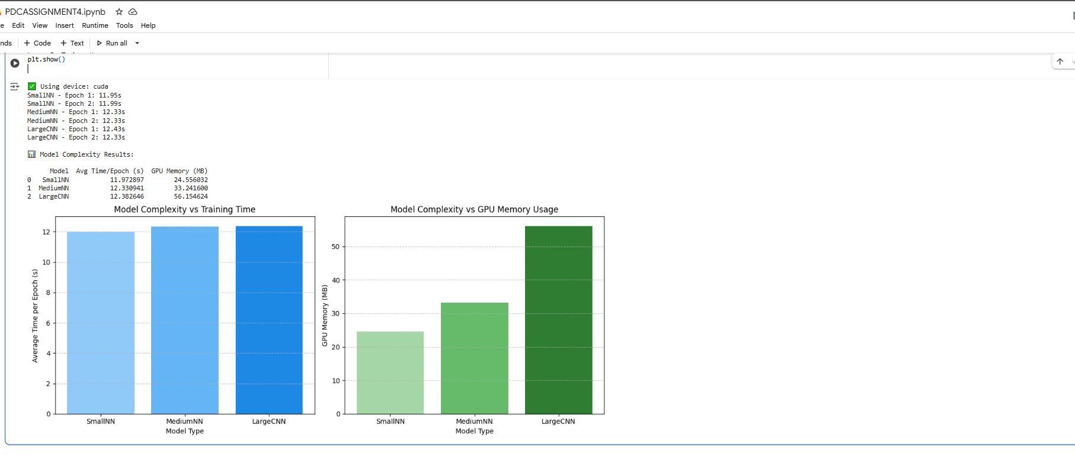

How Model Size Affects GPU Workload and Training Time
When the model size increases (more layers or parameters), the GPU has to perform more computations and store more intermediate activations in memory.
This means:
- Training time increases because the GPU performs more matrix multiplications and backpropagation steps for each batch.
- GPU memory usage rises as larger models need more space to hold weights, gradients, and activations.
- GPU utilization becomes higher, since more parallel operations keep the GPU cores busier.
However, if the model becomes too large, GPU memory can fill up, causing slowdowns or out-of-memory errors. So, while bigger models use the GPU more efficiently, they also require longer training times and more memory.

How GPU Compute and Memory Balance Affect Performance
GPU performance depends on a balance between compute power (number of CUDA cores, clock speed) and memory bandwidth (speed of reading/writing data).
If a model is compute-heavy (many operations per batch) but fits in memory, the GPU works efficiently and training is fast.
But if the model or batch is too large, memory transfers slow things down — the GPU spends time waiting for data instead of computing.
On the other hand, if the model is too small, the GPU cores stay idle because there isn’t enough work to keep them busy.
Therefore, best performance happens when the GPU’s compute units and memory usage are well-balanced — the GPU stays fully occupied without running out of memory.
Part 4: Data Loading and Bottlenecks
# ===========================
# 📘 PART 4: Data Loading and Bottlenecks
# ===========================

import torch
import torch.nn as nn
import torch.optim as optim
from torchvision import datasets, transforms
from torch.utils.data import DataLoader
import time
import pandas as pd
import matplotlib.pyplot as plt

# Device setup
device = torch.device("cuda" if torch.cuda.is_available() else "cpu")
print(f"✅ Using device: {device}")

# ===========================
# 1️⃣ Dataset (MNIST)
# ===========================
transform = transforms.Compose([
transforms.ToTensor(),
transforms.Normalize((0.5,), (0.5,))
])

train_dataset = datasets.MNIST(root="./data", train=True, transform=transform, download=True)

# ===========================
# 2️⃣ Simple Model Definition
# ===========================
class SimpleCNN(nn.Module):
def __init__(self):
super(SimpleCNN, self).__init__()
self.cnn = nn.Sequential(
nn.Conv2d(1, 16, 3, padding=1),
nn.ReLU(),
nn.MaxPool2d(2, 2),
nn.Conv2d(16, 32, 3, padding=1),
nn.ReLU(),
nn.MaxPool2d(2, 2),
nn.Flatten(),
nn.Linear(32 * 7 * 7, 64),
nn.ReLU(),
nn.Linear(64, 10)
)

def forward(self, x):
return self.cnn(x)

# ===========================
# 3️⃣ Training Function (Measures Data Loading Time)
# ===========================
def train_with_workers(num_workers=0, epochs=1, batch_size=128):
loader = DataLoader(train_dataset, batch_size=batch_size, shuffle=True, num_workers=num_workers)
model = SimpleCNN().to(device)
criterion = nn.CrossEntropyLoss()
optimizer = optim.Adam(model.parameters(), lr=0.001)

print(f"\n🔄 Training with num_workers = {num_workers}")

batch_times = []
start_epoch = time.time()

for epoch in range(epochs):
for images, labels in loader:
start_batch = time.time()
images, labels = images.to(device), labels.to(device)
optimizer.zero_grad()
output = model(images)
loss = criterion(output, labels)
loss.backward()
optimizer.step()
end_batch = time.time()
batch_times.append(end_batch - start_batch)

end_epoch = time.time()
avg_batch_time = sum(batch_times) / len(batch_times)
epoch_time = end_epoch - start_epoch

gpu_mem = torch.cuda.memory_allocated(device) / 1e6 if device.type == "cuda" else 0
return avg_batch_time, epoch_time, gpu_mem

# ===========================
# 4️⃣ Run for Different num_workers
# ===========================
results = []
for nw in [0, 2, 4, 8]:
avg_batch, epoch_time, gpu_mem = train_with_workers(num_workers=nw)
results.append({
"num_workers": nw,
"Avg Batch Load Time (s)": avg_batch,
"Epoch Time (s)": epoch_time,
"GPU Memory (MB)": gpu_mem
})

df = pd.DataFrame(results)
print("\n📊 Data Loading Performance Results:\n")
print(df)

# ===========================
# 5️⃣ Visualization
# ===========================
plt.figure(figsize=(12,5))

# --- Avg Batch Load Time Plot ---
plt.subplot(1, 2, 1)
plt.plot(df["num_workers"], df["Avg Batch Load Time (s)"], marker='o', color="#42A5F5")
plt.title("Effect of num_workers on Data Loading Time")
plt.xlabel("num_workers")
plt.ylabel("Average Batch Load Time (s)")
plt.grid(True, linestyle="--", alpha=0.6)

# --- Epoch Time Plot ---
plt.subplot(1, 2, 2)
plt.plot(df["num_workers"], df["Epoch Time (s)"], marker='o', color="#66BB6A")
plt.title("Effect of num_workers on Training Time per Epoch")
plt.xlabel("num_workers")
plt.ylabel("Epoch Time (s)")
plt.grid(True, linestyle="--", alpha=0.6)

plt.tight_layout()
plt.show()

Output:
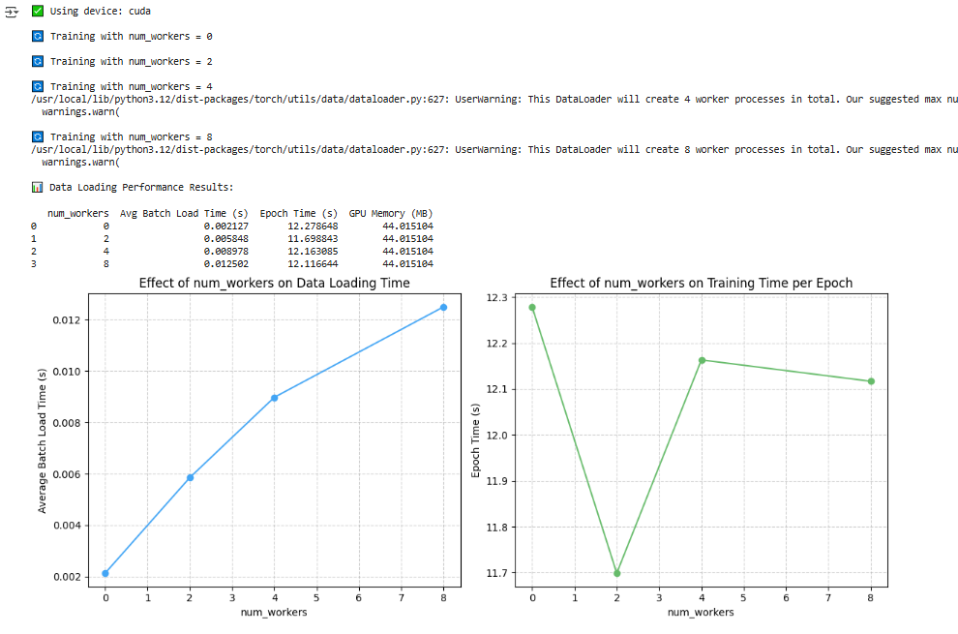
Why inefficient data pipelines cause low GPU utilization.
Inefficient data pipelines make GPU wait idle because data loading and preprocessing on the CPU are too slow.
If the next batch isn’t ready in time, the GPU can’t train continuously, reducing its utilization and overall performance.
How overlapping CPU data loading and GPU training improves performance.
Overlapping CPU data loading with GPU training keeps the GPU busy while the CPU prepares the next batch, reducing idle time and improving overall training speed and performance.
Part 5: Mixed Precision Training (Optional, Bonus)

# ===========================================
# Part 5: Mixed Precision Training (AMP)
# ===========================================
# Part 5: Mixed Precision Training (AMP)
# ===========================================

import torch
import torch.nn as nn
import torch.optim as optim
from torchvision import datasets, transforms
from torch.utils.data import DataLoader
import time
import matplotlib.pyplot as plt

# ------------------------------
# Device setup
# ------------------------------
device = torch.device("cuda" if torch.cuda.is_available() else "cpu")
print(f"Using device: {device}")

# ------------------------------
# Dataset
# ------------------------------
transform = transforms.Compose([transforms.ToTensor()])
train_dataset = datasets.MNIST(root='./data', train=True, transform=transform, download=True)
train_loader = DataLoader(train_dataset, batch_size=128, shuffle=True, num_workers=2, pin_memory=True)

# ------------------------------
# Simple Model
# ------------------------------
class SimpleNN(nn.Module):
def __init__(self):
super(SimpleNN, self).__init__()
self.fc1 = nn.Linear(28 * 28, 256)
self.fc2 = nn.Linear(256, 128)
self.fc3 = nn.Linear(128, 10)

def forward(self, x):
x = x.view(-1, 28 * 28)
x = torch.relu(self.fc1(x))
x = torch.relu(self.fc2(x))
return self.fc3(x)

# ------------------------------
# Training Function
# ------------------------------
def train_model(use_amp=False):
model = SimpleNN().to(device)
optimizer = optim.Adam(model.parameters(), lr=0.001)
criterion = nn.CrossEntropyLoss()
scaler = torch.cuda.amp.GradScaler(enabled=use_amp)

epochs = 3
total_time = 0.0

for epoch in range(epochs):
start = time.time()
model.train()

for images, labels in train_loader:
images, labels = images.to(device), labels.to(device)

optimizer.zero_grad()

with torch.cuda.amp.autocast(enabled=use_amp):
outputs = model(images)
loss = criterion(outputs, labels)

scaler.scale(loss).backward()
scaler.step(optimizer)
scaler.update()

end = time.time()
total_time += (end - start)
print(f"Epoch {epoch+1}/{epochs} | {'AMP' if use_amp else 'FP32'} | Time: {end-start:.2f}s")

torch.cuda.synchronize()
mem_used = torch.cuda.memory_allocated(device) / (1024**2) # in MB
return total_time, mem_used

# ------------------------------
# Run Experiments
# ------------------------------
fp32_time, fp32_mem = train_model(use_amp=False)
amp_time, amp_mem = train_model(use_amp=True)

# ------------------------------
# Compare Results
# ------------------------------
print("\n=== Comparison ===")
print(f"FP32 - Total Time: {fp32_time:.2f}s | GPU Memory: {fp32_mem:.2f} MB")
print(f"AMP - Total Time: {amp_time:.2f}s | GPU Memory: {amp_mem:.2f} MB")

# ------------------------------
# Plot Results
# ------------------------------
labels = ['FP32 (Standard)', 'AMP (Mixed Precision)']
times = [fp32_time, amp_time]
memories = [fp32_mem, amp_mem]

fig, ax1 = plt.subplots()

ax1.bar(labels, times, color='skyblue')
ax1.set_ylabel('Training Time (s)', color='blue')
ax1.set_xlabel('Precision Mode')
ax1.tick_params(axis='y', labelcolor='blue')

ax2 = ax1.twinx()
ax2.plot(labels, memories, color='red', marker='o', linewidth=2)
ax2.set_ylabel('GPU Memory (MB)', color='red')
ax2.tick_params(axis='y', labelcolor='red')

plt.title('FP32 vs Mixed Precision Training (AMP)')
plt.show()

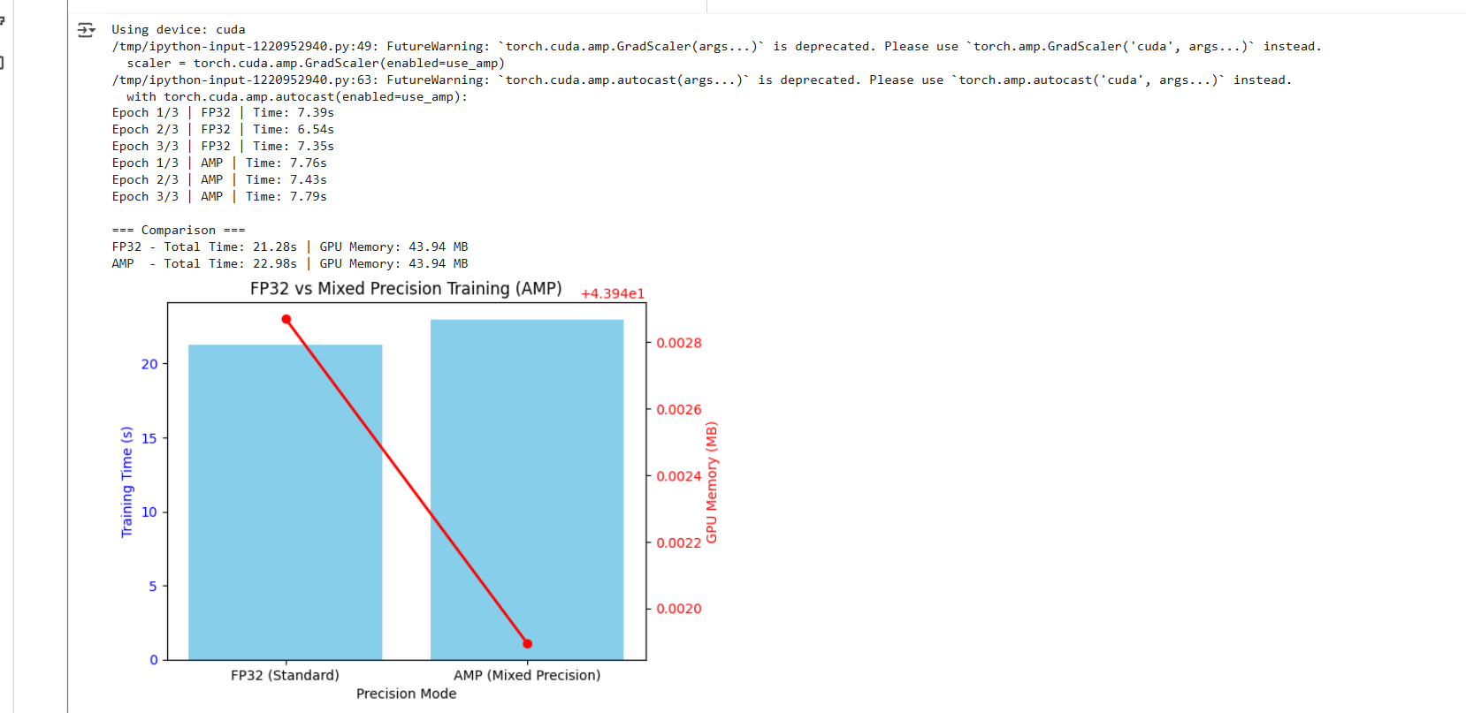

How FP16 training improves throughput.
FP16 (half precision) training improves throughput because it uses smaller data types, allowing faster computations and reduced memory usage, which lets GPUs process more data in parallel.
When it might cause numerical instability.
FP16 training can cause numerical instability when values are too small or too large, leading to underflow or overflow, especially in layers with very small gradients or large weight updates.
Discussion Questions

Question1) What factors most affect GPU training performance (batch size, model size, precision,data pipeline)?
Answer:

Factors That Most Affect GPU Training Performance

🧩 (a) Batch Size
- Effect: Larger batch sizes allow GPUs to process more samples in parallel, better utilizing thousands of GPU cores.
- Up to a limit: When the batch size fits comfortably in GPU memory, throughput increases and training becomes faster.
- Beyond that limit: Too-large batches can cause out-of-memory (OOM) errors or slower convergence (worse accuracy).
- Example:
  - Batch = 16 → GPU underutilized, lots of idle time.
  - Batch = 256 → GPU fully utilized, maximum throughput.
  - Batch = 4096 → GPU memory overflow or degraded model performance.
🧠 Summary: Batch size directly controls how much of the GPU’s compute potential is used at once.

🧠 (b) Model Size / Complexity
- Effect: Larger or deeper models have more parameters and operations (FLOPs), increasing GPU workload and training time per epoch.
- Balance needed:
  - Too small → GPU stays idle, computation is trivial.
  - Too large → GPU spends more time computing or runs out of memory.
- Example:
  - A 2-layer MLP might barely use GPU resources.
  - A deep CNN (like ResNet50) can fully load GPU compute units and memory.
🧠 Summary: Model complexity must match GPU capacity to achieve efficient utilization.

(c) Precision (FP32 vs FP16)
- Effect: Lower-precision arithmetic (like FP16) reduces memory usage and speeds up computation, especially on modern GPUs with Tensor Cores.
- Mixed Precision Training (AMP):
  - Uses FP16 for most computations, FP32 for stable operations (like loss accumulation).
  - Gives 30–50% speedup and less memory usage.
- Trade-off: Slight risk of numerical instability or underflow in older GPUs or sensitive models.
🧠 Summary: FP16 improves throughput and memory efficiency, with minor accuracy trade-offs.

(d) Data Pipeline (CPU → GPU Transfer & Loading)
- Effect: If data loading (CPU-side preprocessing) is slow, GPU sits idle waiting for input — this drastically reduces utilization.
- Fixes:
  - Use num_workers > 0 in DataLoader (multi-threaded loading).
  - Enable pin_memory=True for faster CPU→GPU transfer.
  - Overlap data loading with GPU computation (asynchronous pipelines).
- Example:
  - num_workers=0 → GPU idle 40–60% of the time.
  - num_workers=4 → GPU continuously busy, faster training.
🧠 Summary: Efficient data pipelines keep GPUs continuously fed with data.

Question 2) Why might small models not benefit much from GPU acceleration?
Answer:
Small models might not benefit much from GPU acceleration because they don’t have enough computations to fully use the GPU’s parallel processing power. The time spent transferring data between the CPU and GPU and managing GPU tasks can be greater than the actual computation time. As a result, the GPU stays underutilized, and the CPU can sometimes train small models just as fast or faster.
Question 3) How can you minimize GPU idle time during training?
Answer:
You can minimize GPU idle time during training by improving data loading and keeping the GPU continuously busy. Use multi-threaded data loading (num_workers > 0 in PyTorch DataLoader) so the next batch is ready while the GPU is still training. Also, prefetch and cache data, use larger batch sizes to increase GPU workload, and ensure asynchronous data transfers between CPU and GPU. Finally, monitor bottlenecks with tools like nvidia-smi to balance CPU preprocessing and GPU computation.
Question 4) What are the trade-offs between higher batch size and model accuracy?
Answer:

Trade-offs Between Higher Batch Size and Model Accuracy

🧠 1. Training Speed
- Higher batch size increases GPU efficiency and parallelism.
- It reduces the time per epoch and makes training faster.

🎯 2. Generalization and Accuracy
- Very large batches can cause the model to generalize poorly.
- The model updates weights less frequently, missing small variations in data.

⚖️ 3. Gradient Quality
- Smaller batches produce noisier gradients, which can help escape local minima.
- Larger batches give smoother gradients, which may lead to suboptimal convergence.

📉 4. Memory Usage
- Larger batch sizes require more GPU memory, which may limit how big the model can be.
Question 5) Why does data transfer between CPU and GPU sometimes become a bottleneck?
Answer:

1. Slow Communication Bus
- Data moves between the CPU and GPU through the PCIe bus, which is much slower than GPU memory speed.
- Frequent transfers can delay training because the GPU has to wait for data to arrive.

💾 2. Large Dataset Size
- When large batches or images are sent repeatedly, the transfer time increases, causing the GPU to stay idle during data movement.

🧠 3. Inefficient Data Pipelines
- If data preprocessing (like augmentation or loading) happens on the CPU slowly, it delays the next batch, further reducing GPU utilization.

🔄 4. Synchronization Overhead
- Each transfer may involve synchronization between CPU and GPU, adding extra latency.

